52

**To Apply to the COSA Program, Please Contact Your Facility Case Worker and Request an Application**

Case Workers: To Request Additional Information,

Please Contact:

Lee King

*Restorative Reintegration Specialist*

802-752-7030

lee@fgirjc.org



**Franklin**

**Grand Isle**

**Restorative**

**Justice Center**

**120 North Main Street**

**Saint Albans, VT 05478**

**802-524-7006**

**Circles of Support & Accountability**

**COSA**

Do you feel unsupported in the community? Would you benefit from built-in relationships with a small group of community members? Consider having a COSA team!

Reentering the community after being in prison can be a very challenging process. These challenges can often be overwhelming, particularly for people who have been in prison for a significant amount of time. Things like getting an identification card, finding employment and getting connected to community resources can be a huge obstacle.

Circles of Support and Accountability (COSA) programs have been shown to be an effective way to help returning community members meet the conditions of furlough and avoid re-incarceration or re-offending while becoming engaged and productive members of the community.

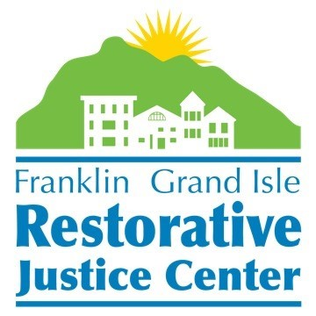

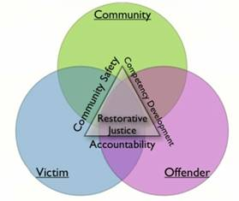

**Who Is Eligible?**

If you are within one year of your minimum sentence and are considered “high risk/high needs” based on your ORAS/Risk Assessment scores, then you are eligible to apply to the COSA program. **If you are interested in applying for COSA please contact your facility Case Worker and fill out an application.** If you are an eligible candidate, the COSA Reentry Coordinator will schedule an in-person intake interview with you in facility. Your case will then be presented to a Community Reentry Panel who will determine if you are accepted into the COSA program based on a number of factors, including your criminal history, behavior in facility, programming, risk level, etc. The Community Reentry Panel meets once a month. After the Panel makes a decision, the Reentry Coordinator will inform you and your Case Worker of the decision. COSA is a supportive service that is separate and apart from housing. COSAs are available to individuals who reside in our Transitional House and also for community members living elsewhere.

**What Is COSA?**

**The goal of COSA is “*no more victims*.”**

A COSA team is made up of three volunteers, one staff person, and one Core Member. The Core Member is the person who is returning to the Franklin and Grand Isle County communities from incarceration. The COSA team meets one hour per week for a year to provide support and mentoring. The team aims to ensure that the Core Member is accountable for their actions, and collaborates with Probation and Parole to provide a supportive structure. Core Members who are accepted into the program will have expressed a desire to change and must be committed to following the guidelines of the program. Core Members are encouraged to meet with their volunteers outside of COSA to engage in prosocial activities such as getting coffee, going for walks, shooting hoops, grabbing lunch, etc.

Some of the goals of a COSA are to improve community safety and repair relationships by supporting Core Members in successfully rejoining the community and preventing future crimes.   The COSA circle helps the Core Member take the skills and knowledge they learned in treatment and use those in everyday life. The circle also holds the Core Member accountable and helps participants develop healthy relationships. As the Core Member grows and rebuilds community connections, the circle will provide support and guidance to the Core Member both in the circle and in the community.

The COSA program provides a restorative approach to justice by supporting, building and maintaining healthy patterns of living for Core Members as they reenter the community.  The circle represents a bond of mutual respect, understanding, and ownership in this process.  Volunteers share their own stories and struggles in order to connect with participants and help Core Members build on the life experience of others.